NAME : MALHARA R.M.Y.S

REG. NO. : 2022/E/126

DATE ASSIGNED : 15 JUNE 2023

EC1011: COMPUTING

LAB 07: Domain Specific Programming Languages

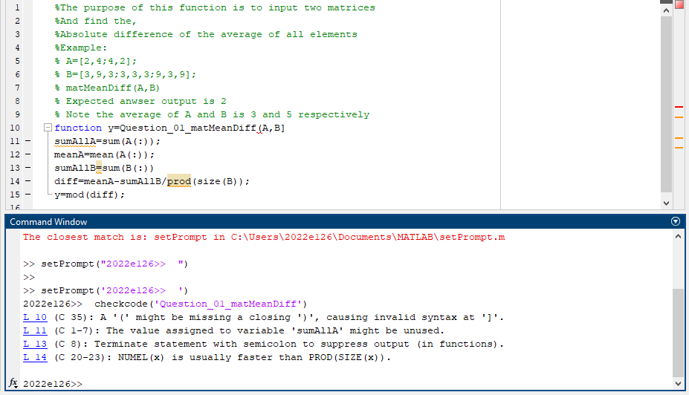 01. (a)

(b)

|  |  |  |
| --- | --- | --- |
| No. | Field | Data |
| L10 | Description | A '(' might be missing a closing ')', causing invalid syntax at ']'. |
| Type | Error |
| Actual line | function y=Q01_matMeanDiff(A,B] |
| Corrected | function y=Q01_matMeanDiff(A,B) |
| L11 | Description | The value assigned to variable 'sumAllA' might be unused. |
| Type | Warning |
| Actual line | sumAllA=sum(A(:)); |
| Corrected |  |
| L13 | Description | Terminate statement with semicolon to suppress output (in functions). |
| Type | Warning |
| Actual line | sumAllB=sum(B(:)) |
| Corrected | sumAllB=sum(B(:)); |

|  |  |  |
| --- | --- | --- |
| L14 | Description | NUMEL(x) is usually faster than PROD(SIZE(x)). |
| Type | Warning |
| Actual line | diff=meanA-sumAllB/prod(size(B)); |
| Corrected | diff=meanA-sumAllB/numel(B); |

(c)

(ii)

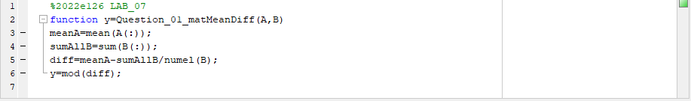

(iii)

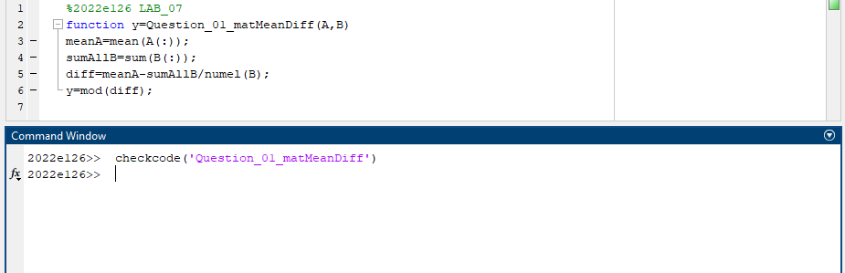

(iv)

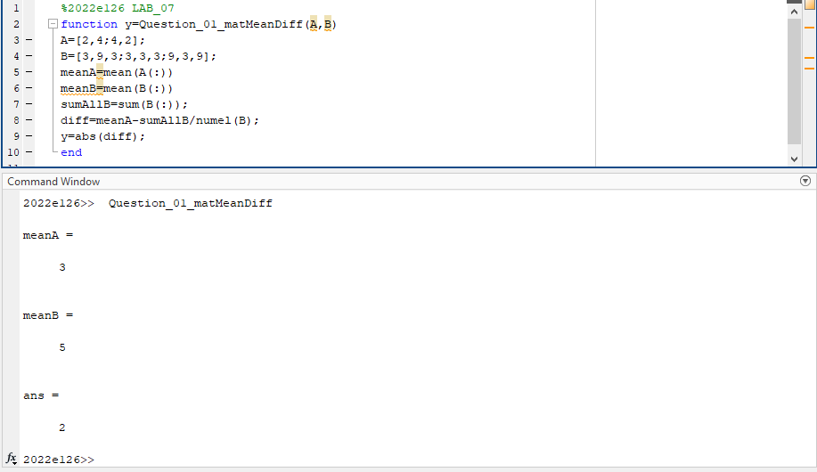

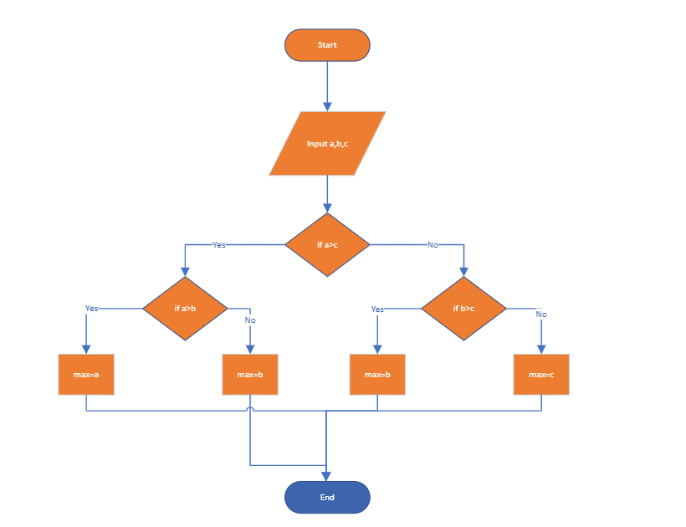 02. (a)

(b)

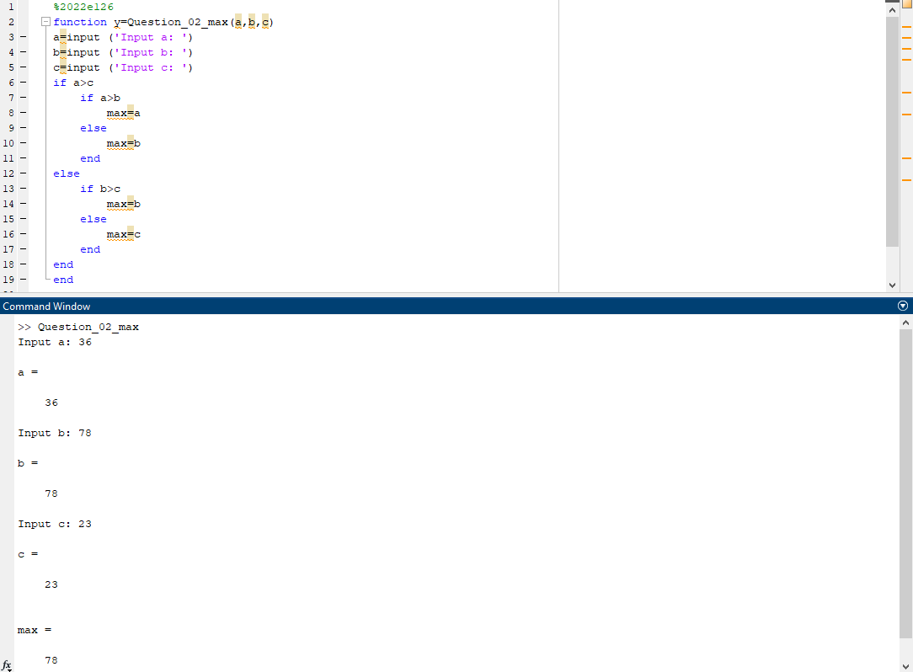

03. (a)

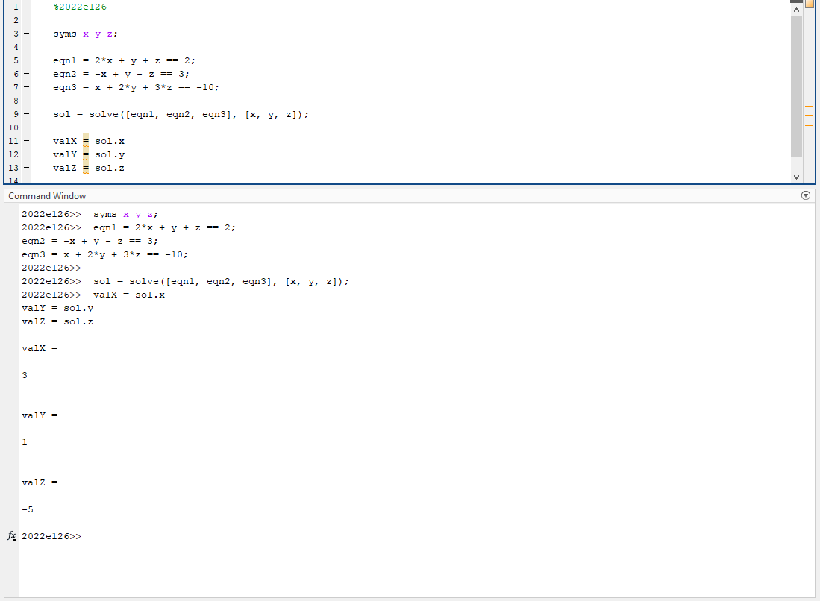

(b)

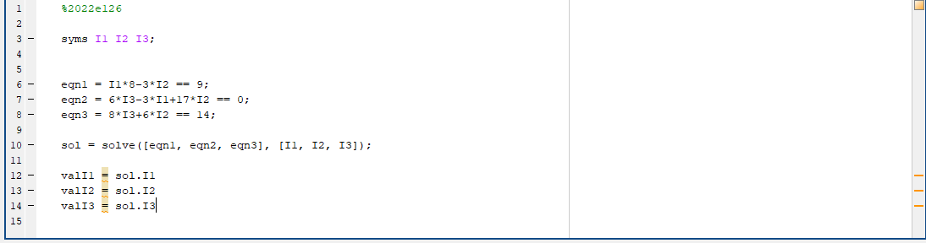

(c)

